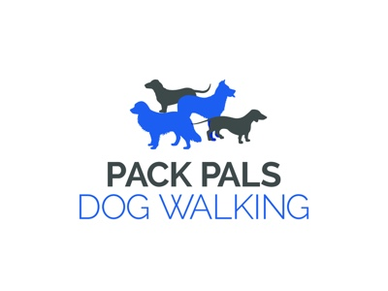

Pack Pals Pricing April 2019:

*Walking Prices increase to time and half after 5pm and double time on bank holidays and weekends*

Group Walks: Solo Walks:

1 Dog x 30 Min - £7.50 1 Dog x 30 Min - £12
1 Dog x 60 Min - £11.50 1 Dog x 60 Min - £20
2 Dog x 30 Min - £11.50 2 Dog x 30 Min - £20
2 Dog x 60 Min - £17 2 Dog x 60 Min - £30
3 Dog x 30 Min - £16
3 Dog x 60 Min - £25

House Visits:

We offer two options, a pop in and out visit or a 30 minute visit where we spend that extra bit of time loving your pet and providing interaction.

Cat Visit - £6.50
30 Min - £11.50

Not found what you are looking for?
Contact us to arrange something a little different, we will do our utmost to assist you and your pet in anyway we can.

